PyGame – End of unit Evaluation
Points to include in your evaluation:
- Purpose of the PyGame Unit.
- What went well? (WWW)
- Even Better If… (EBI)
- Reflection - What could you improve? How/ Why/Work Ethics/Targets?

Take a screenshot of your progress ladder table and the graph and replace the examples below:
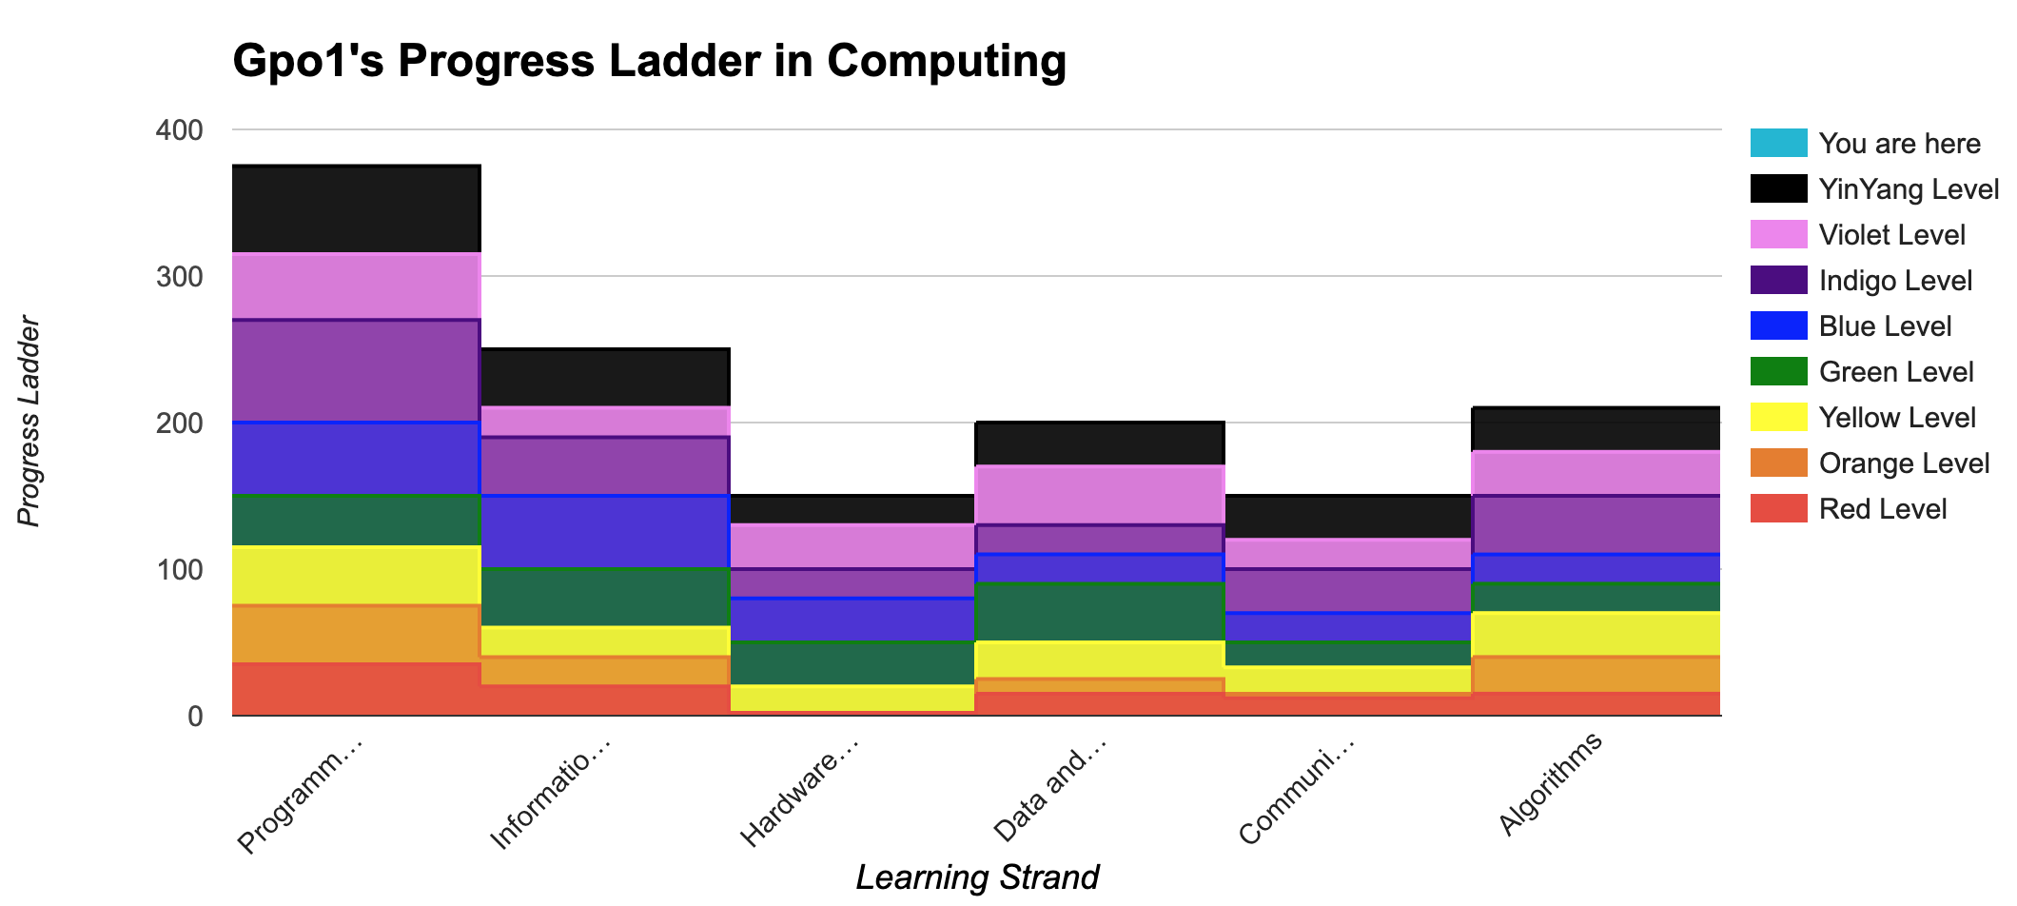
Programming and Development:
- Design a simple program that runs by following a sequence of instructions.
- Declares and assigns functions, variables, appropriate use of sequence, selection (if statements) and repetition (loops) to change variable values for sprite x,y coordinates.
- You will demonstrate use of: arithmetic operators(*+-//,/,%), relational operators (<=,>=,+=,-=,*=,:=,==), conditional if statements, and loops within your programs.
- Declares and assigns data structures(lists) to store a list of scores or hits etc...
- Import and use various library functions (maths, sys, random).
WWW:

EBI:

Algorithms:
- Design algorithms using a sequence of instructions, iteration(repetition/loops), and selection(if statements).
- Students will understand that selection(if Statements) is used to change the outcome of a program based on certain conditions.
WWW:

EBI:

Literacy:
- You will be able to demonstrate the correct use of grammar, punctuation and spelling of keywords throughout this project and including this evaluation.
WWW:

EBI:

Information Technology:
- You will be able to create, store and edit digital content(Your work) using appropriate file and folder names.
- You will also be able to explain your work and make improvements to solutions based on feedback received (BTL).
- You will be able to demonstrate that you have used a variety of software to manipulate and present digital content. (Python IDLE/Thonny, Snipping tool, Paint, Word & BTC)
- You will be able to demonstrate an awareness for the quality of digital content collected. (Images used as sprites, backgrounds and audio)
WWW:

EBI:

Reflection/Work Ethics/Targets:

Grading of your work – Badges | Y/N
Bronze: Briefly evaluated all learning strands of this unit.

Silver: Evaluated all learning strands of this unit with WWW and EBI on all strands.

Gold: Evaluated all learning strands with WWW and EBI on all strands with good use of punctuation, spelling & grammar.
Platinum: All the above, and included a self-reflection on work ethics.

